**Experiment-2**

**Aim: Working with Docker (Basic Commands)**

1. Search for an image on Docker Hub like: python

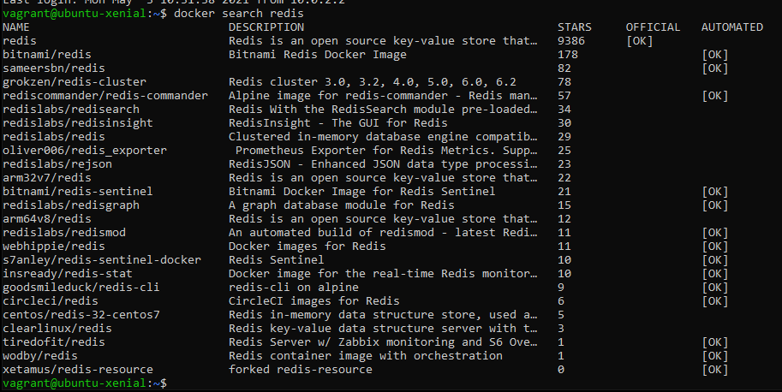

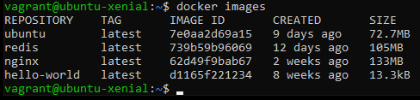

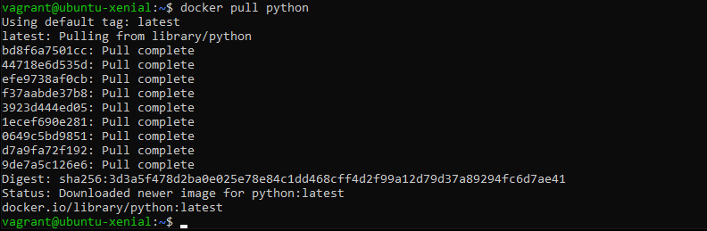

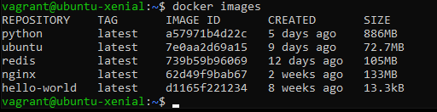

1. Run Docker Conatiner of Redis image in background

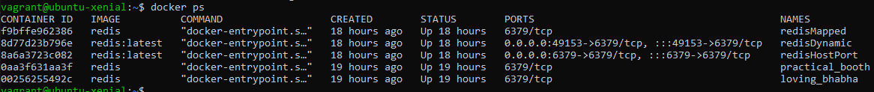



1. Run Docker ps and Docker ps -a

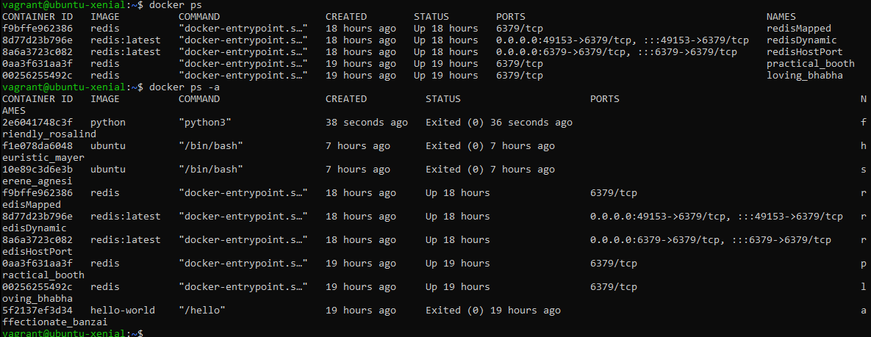

1. Run Docker Container and take its console.

